Chapter 11, Problem 30.

Compute the rms value of the waveform depicted in Fig. 11.61.

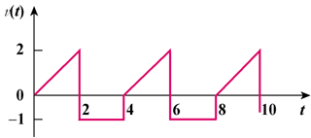

Figure 11.61
For Prob. 11.30.

